**Project P**



**[If you already have a logo, put it here, if you have a studio you can do the same]**

**Build, upgrade and defend your Sanctuary**

Contents

**I. Game Overview 4**

**a. Manage, explore and create bonds. 4**

**b. Story and Themes 4**

**c. Genre 5**

**d. Target Audience 5**

**e. Platform and Tools 5**

f. Genre innovations 5

**II. Playability and Mechanics 6**

**a. Main Game View 6**

**b. UI 6**

**c. Main mechanics 10**

a. Master Collector 10

**b. Evolution doctorate 10**

**c. Sanctuary legend 10**

d. Renovation lord 10

**e. Settings Guru 10**

g. Extra mechanics 11

**d. Game Controls 11**

**III. Core Gameplay Loop 12**

**IV. Game Elements 14**

**a. Main Characters 14**

**b. Main Menu 14**

**c. Intro Sequence 15**

**d. End Condition 15**

**V. Sound 16**

**a. Music 16**

**b. Sound Effects 17**

**c. Voice Lines 17**

**VI. Mini Art Bible 17**

a. Art Style 17

b. Characters 18

c. Backgrounds/Levels 19

d. Others 19

**VII. Implementation Pipeline 19**

**● Character script; 20**

**● Healers; 20**

**● Shops; 20**

**● Conditional Unlocks; 20**

**● Event handler; 21**

**The team: 22**

# **Game Overview**

## Manage, explore and create bonds.

The player grew up with his family taking care of the town sanctuary, they wanted to work outside of the town they were born in, but had to come back on their parents request. In this journey the player will discover themselves while creating new relationships and bonding with different monsters (hereby called creatures), the player will be in an unfamiliar situation having to juggle responsibility and adventure until their parents come back.

## Story and Themes

The story starts with the “incident”, a person holding a baby receives a package with a note, inside there are some cards, the person takes a liking to the cards, some time later, the town is seen with a lot of people playing with similar cards, and then followed by a big explosion the content of every card (creatures) is manifested into reality.

Then, cut out to a person at the tender age of 18, the player, leaving home to study in another town accompanied by some of those creatures, with 22 their parents asked them to come home and take care of the Sanctuary, the place the player lived before. Albeit reluctant, they thought they did not have any other choice and went back home

After the initial section, the story would follow the player as they started cleaning the sanctuary (they would be surprised as why it was so dirty), made new friends and joined a ranger group to explore the nearby areas while learning more about the reason the creatures of the cards were real. The FINAL twist would put the player facing the fact that the ones that introduced the cards to their continent were their parents and that the cards were devices created to capture the creatures from another continent.

Besides the main story, the player would also have some side stories related to the ranger group and the sanctuary itself, letting the player strife between their longing for adventure and their duty to the sanctuary. This would lead the player to split their time between improving the sanctuary and creating a place for people to battle them and adventuring to get more creatures.

The story revolves around 2 more themes besides adventure and responsibility, they would be companionship and perseverance. The player will get to be in contact with companionship as they partake in missions with the rangers and decide the value of having someone to be in contact with. All of this mixed with feelings of betrayal, love, friendship and everything that one could think of about relationships (be they right or wrong). Perseverance, albeit present in every scenario, would be more prevalent during the “cleaning” of the sanctuary, the player would be faced with adversities and question the importance of not giving up.

## Genre

Simulation, RPG, Turn-based-Combat, Collectathon, management.

## Target Audience

16+, Although collectathons/RPGs of this type are familiar to every age, the themes and story are meant to be a bit more mature.

## Platform and Tools

The initial vision for this game is around computers, specifically using unreal (preferably 5) as the engine, c++ for coding and blender +substance painter for 3D assets.

## Genre innovations

While there are alot of simulator rpg games (like stardew valley and harvest moon) and collectathons (pokemon and digimon), there’s not many that blend these 2 genres well while also giving you great customization tools to decide how you want to play. Because of this, this game is looking to strike the perfect balance between both, having you take care of the sanctuary and going on adventures as a ranger giving a refreshing and new experience for veteran and newer players alike.

Another thing that many RNG games lack is a good sense of freedom on how to progress the story and some monsters feel like they are restricted because of the places that you are allowed to go. The goal with this game is to create various options so the player can choose what to explore first while still having a cohesive story, making it a personalized experience akin to a choose your own adventure, but one that, as said, still follows the same cohesive story.

To finalize, these types of games generally have one difficulty setting, something that for some time now has been talked about in those games community, forcing them sometimes, like the pokemon community, to create arbitrary rules to increase the users enjoyment and the difficulty of the game. Having this in mind, the game will give the player an array of options to customize their experience, having the option to share and import settings so communities can still have a shared experience.

The evolution system in Rpg Colecathons normally follow a linear path were almost all monsters share the same evolution pattern, ex.: reach lvl X, use item Y, and each monster has a unique evolution line. Project P is set to take a different approach, every creature will share in some way an evolution line with another, and every evolution line will have specific conditions to evolve to the most powerful creatures.

**Honorable mention:** There are no initial plans for a PvP area/mode, but if it were to happen, another differential would be the option to utilize “perfect” creatures, giving the player the option to perfectly create a team without wasting time in “training” their team.

# **Playability and Mechanics**

## Main Game View

Third person view

## UI

This are sketches for the menu ui, 3 different iterations but all of them can mix and match, not final by any means

1. First iteration

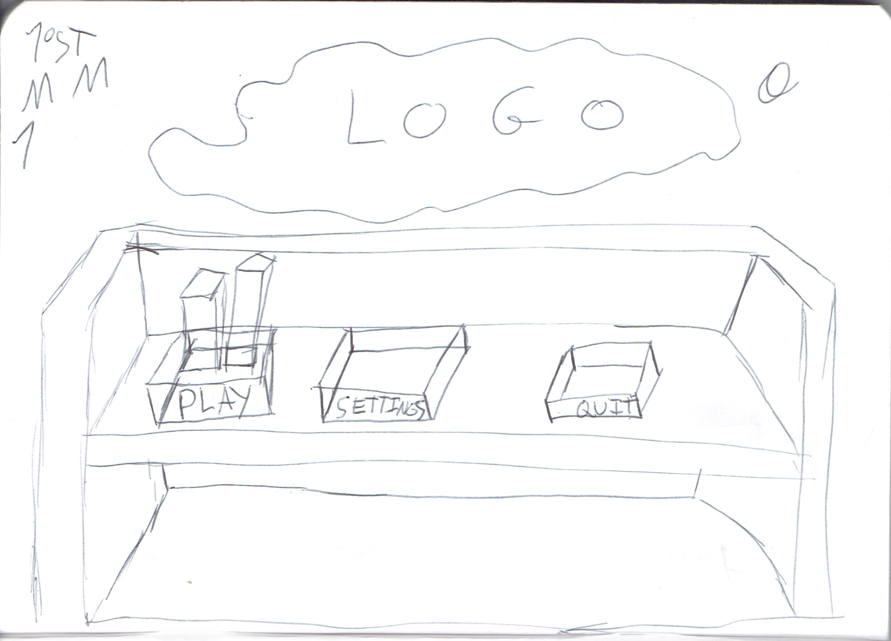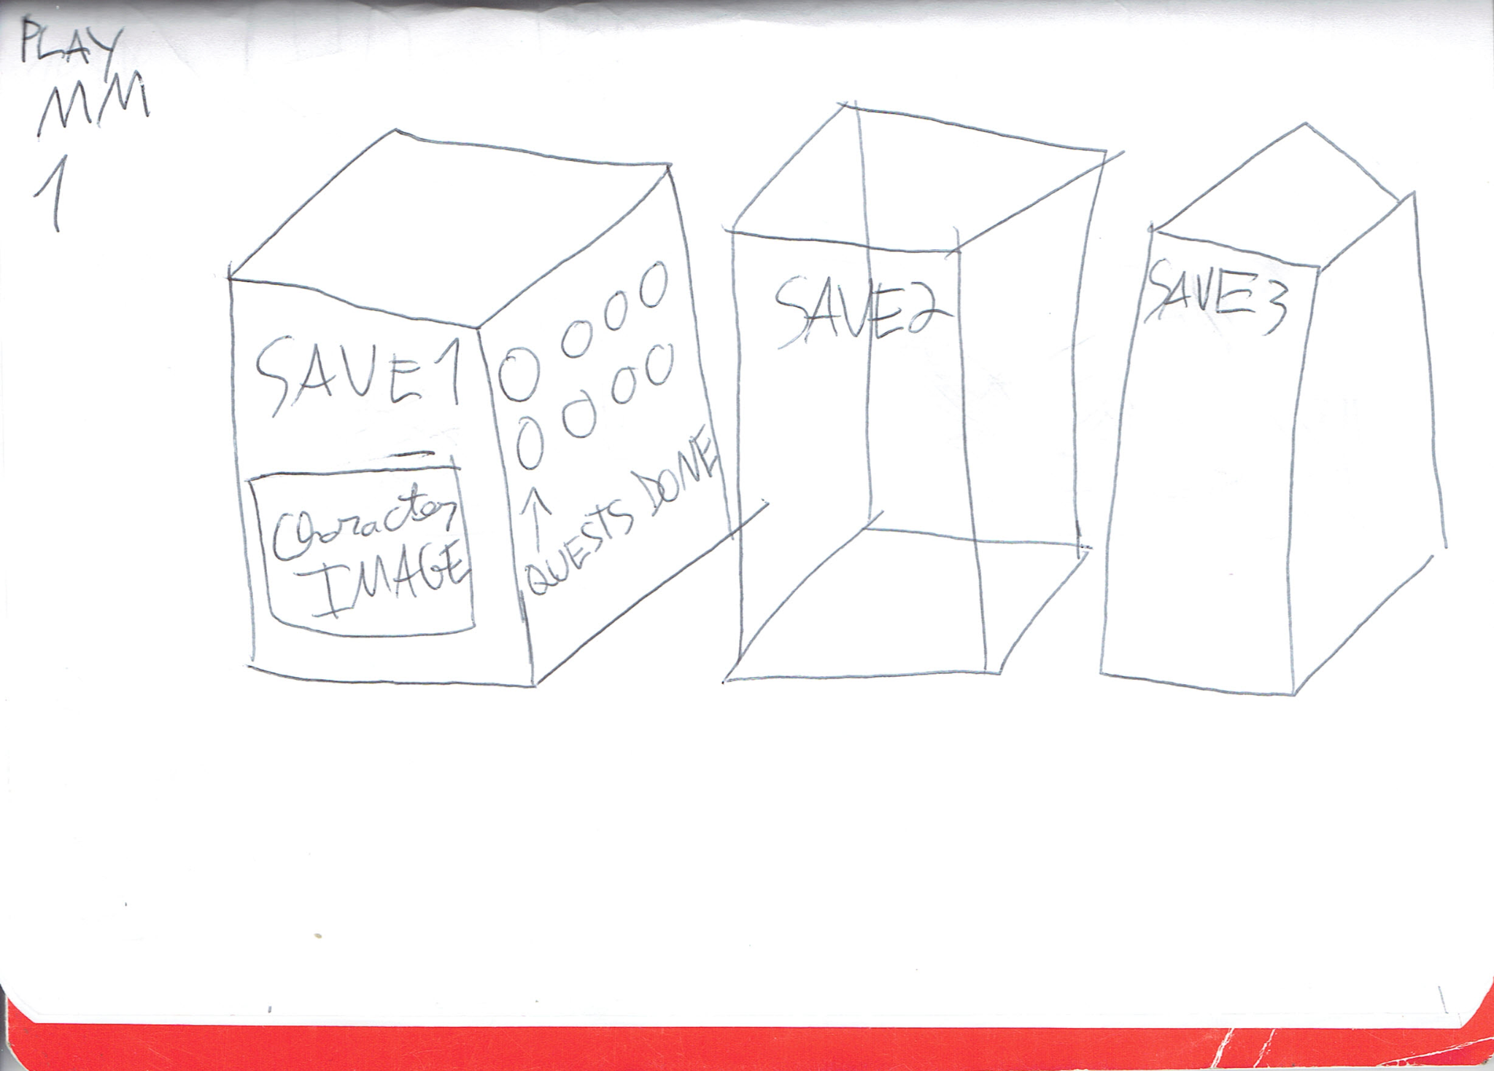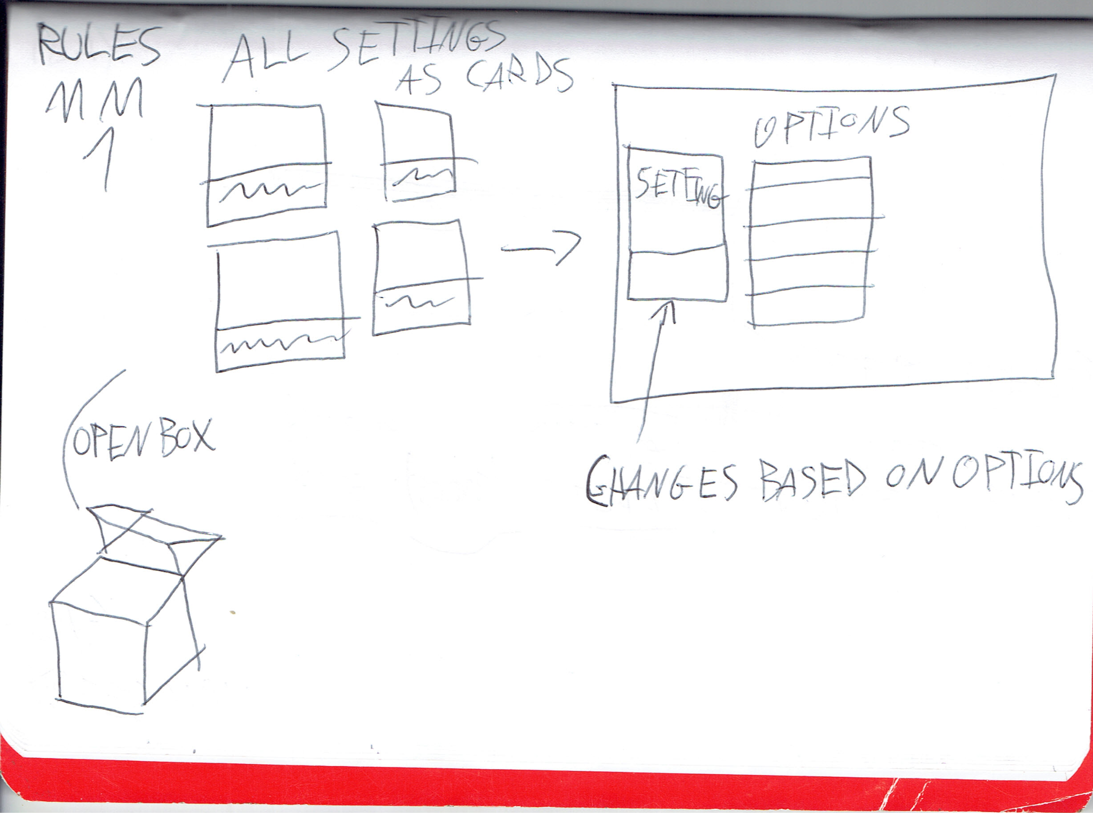

1. Second iteration

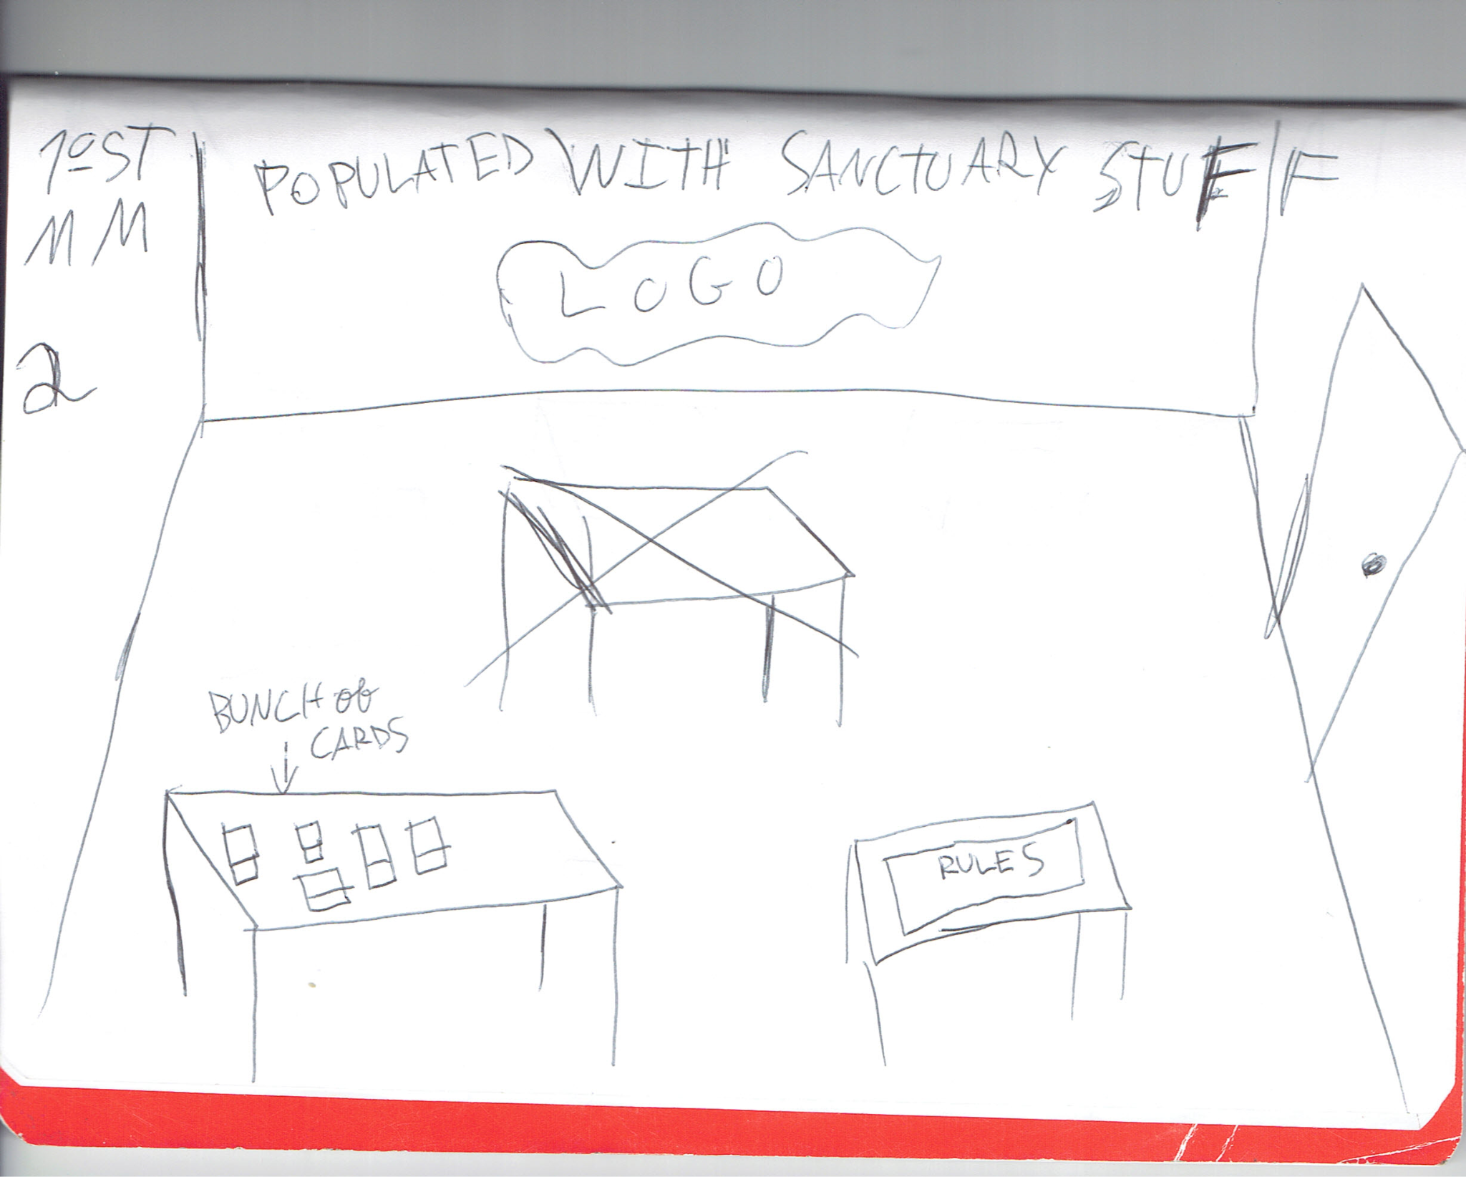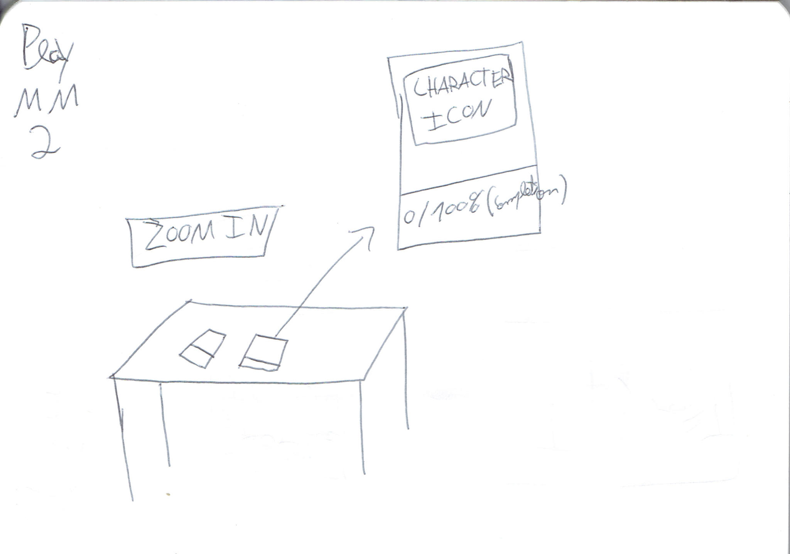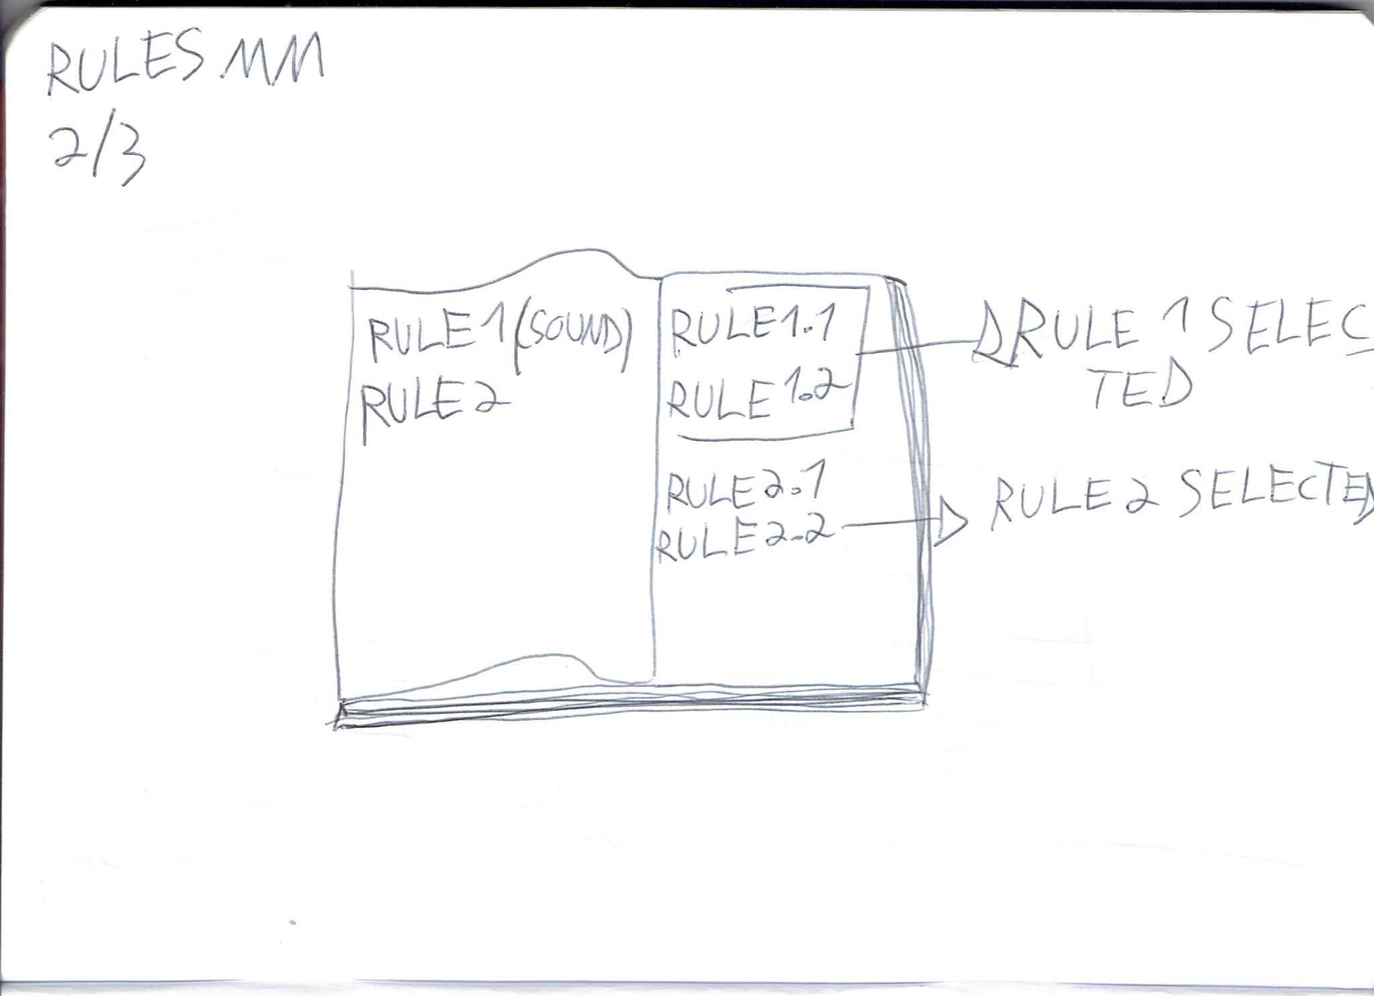

1. Third iteration

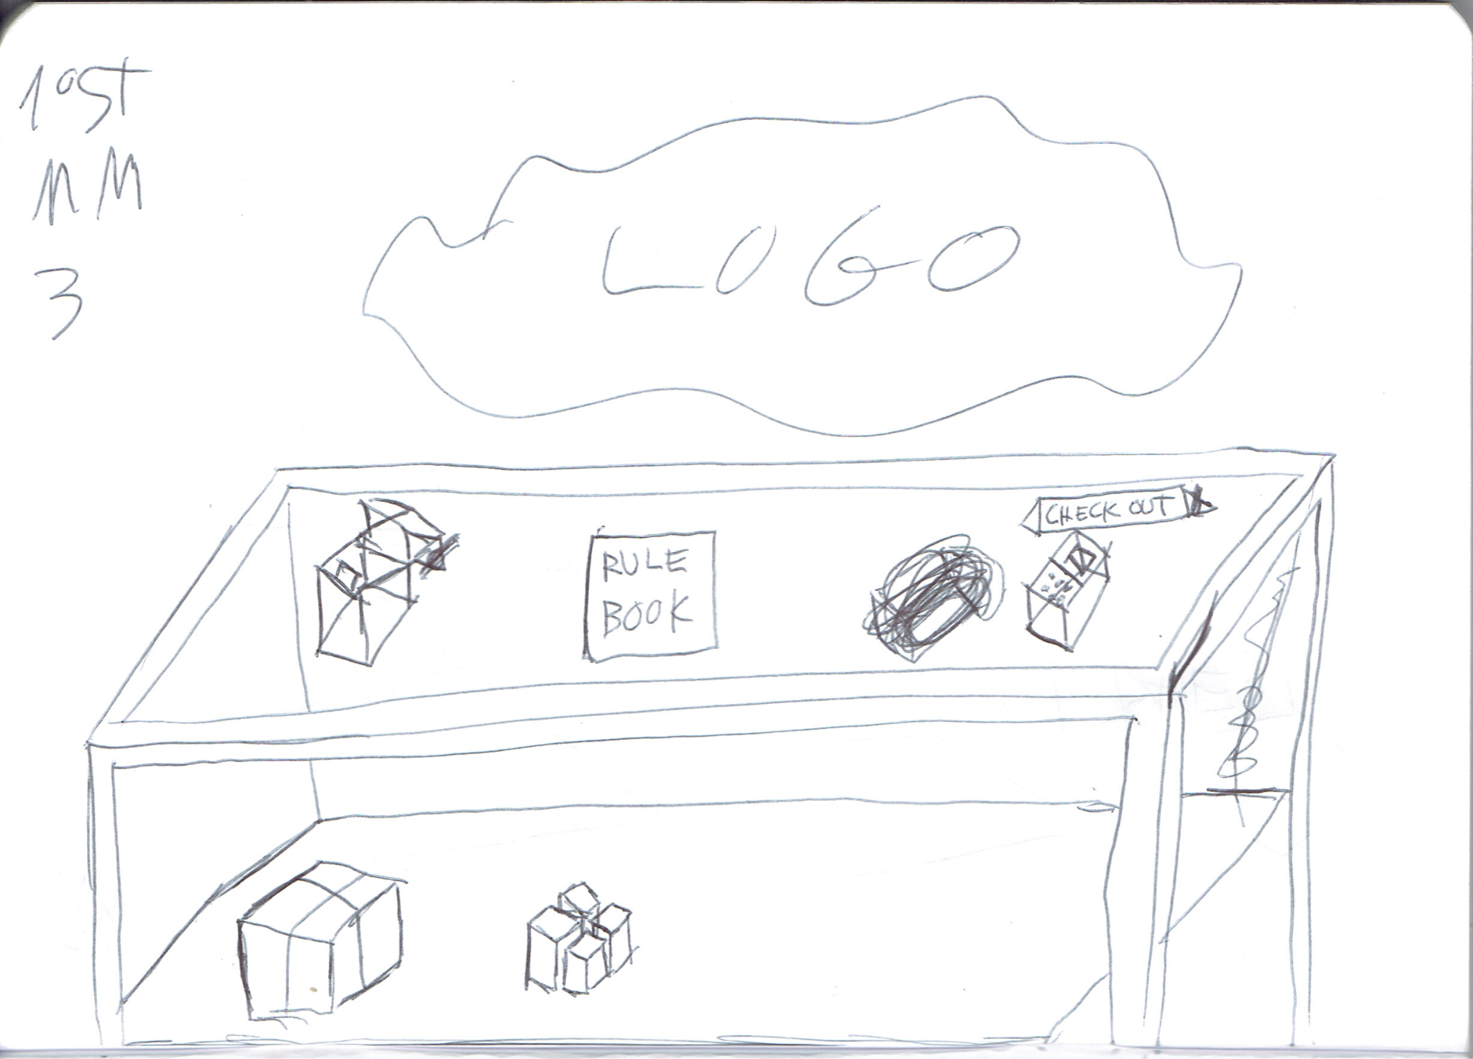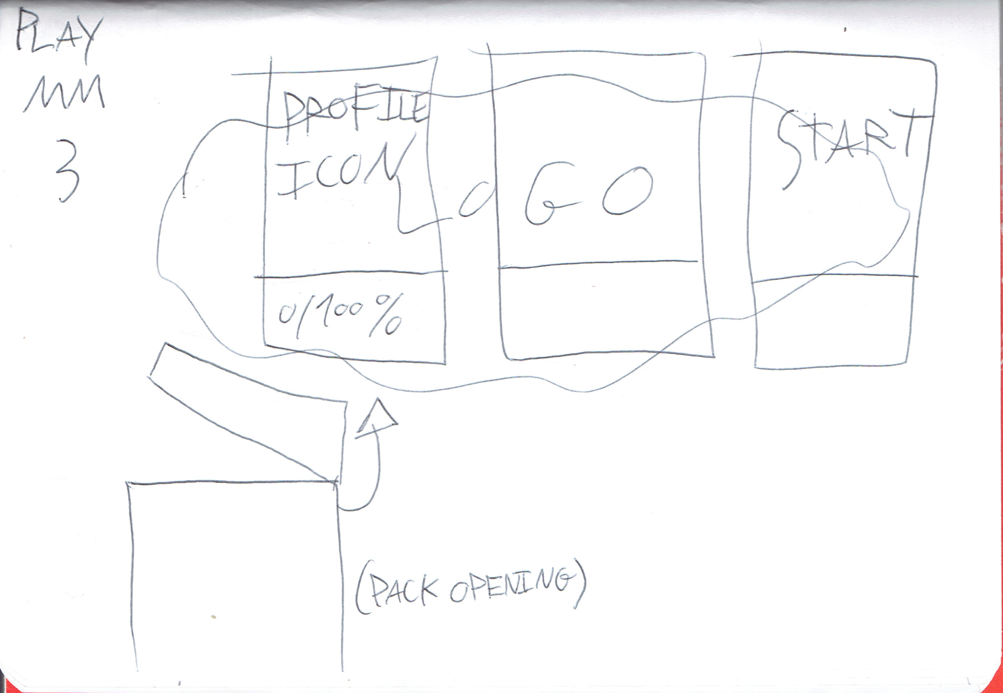

## Main mechanics

## Master Collector

Catching creatures and turning them into cards to use in battle and other different activities. The player will be able to do all that and doing so will lead them to catch all creatures and complete the compendium, getting extra rewards in the process.

## Evolution doctorate

Evolving creatures require reaching certain goals, some of these goals may be shared like using an item or reaching a certain level, but each “end of road” evolution is expected to have a unique evolution goal.

There’s a shared evolution tree for many creatures but some evolutions are locked behind eggs, this means that the player will be required to breed their creatures and have a creature from an egg to unlock them.

## Sanctuary legend

Instead of looking for specialized opponents to fight against, the player will utilize the sanctuary to receive challengers, and if they wish, create a specialized sanctuary themselves. Receive rewards as the player defeats challengers and creates the most famous Sanctuary.

## Renovation lord

Using materials to evolve the Sanctuary and unlock new furniture, the player will have the option to remodel it as they see fit. The player will also be able to choose from different Sanctuary types and create a unique specialized style.

These materials will be able to acquire by farming them (or something similar with the same effects), foraging and crafting. The player will also use these crafting “recipes” for day to day items.

## Settings Guru

The player will have the option to customizer their experience via different settings, they will be able to do stuff like.: Play with all enemies having the same lvl as their creatures; Make every creature appear outside of combat as an unknown creature; make it so a creature is automatically destroyed if defeated in battle; change encounter tables so they are randomized, and many more.

* 1. Encounter Bachelor

Older RPGs have random encounters, be it in specific zones, like grass in Pokémon, or in all of the overworld, like in the early Final Fantasy games. New games tend to look for what I'll call an “open” approach (making the old way a “close” approach), where the creatures that the player encounters are visible in the overworld, like the newest Pokémon, Pokemon Scarlet and Violet. Most players do prefer this open approach, however, I think the problem is not the close approach itself but how it was used. Because of that this game will use both approaches. Using a system where closed off areas like caves will follow a close approach and only if the player fully illuminates them will they unlock an open approach, the idea is for the night cycles to follow this close approach as well, while the day cycles in the other areas would follow the open approach. This would increase the danger of traveling without care but without becoming too annoying, making it so that choosing to proceed or retreat becomes a meaningful choice.

## Extra mechanics

**Create relationships-** speaking and giving gifts to different characters will improve the players relationship with them, gaining some perks and unlocking story bites exclusive to those characters.

**Advise researcher-** Whenever the player wants to find out how to evolve a creature, they will be able to talk to the researcher, and the researcherwill give a hint for a rancom creature the player owns, with the option to pay some materials to learn more information, or to specify what creature to get information on.

## Game Controls

The objective is to give full key bind control, but for a standardized view, the following table has a proposition of what to press to play the game.

| Key binds | Function |
| --- | --- |
| W, A, S, D | Standard movement |
| Shift | Crouch |
| Mouse | Standard 3D look controls |
| Left Mouse Click | General interaction |
| E | Pick-ups |
| Tab | Game Menu |
| Escape | Configurations menu |
| CTRL | shift between running and walking |
| M | Map |

# **Core Gameplay Loop**

The main gameplay loop could be summarized by:

Explore→ fight→ catch/defeat→ gather materials→ plant/take care of crops → evolve Sanctuary→ defend Sanctuary→ talk with characters→ repeat

The following is a draft of a flowchart with the main interactions/gameplay loop.

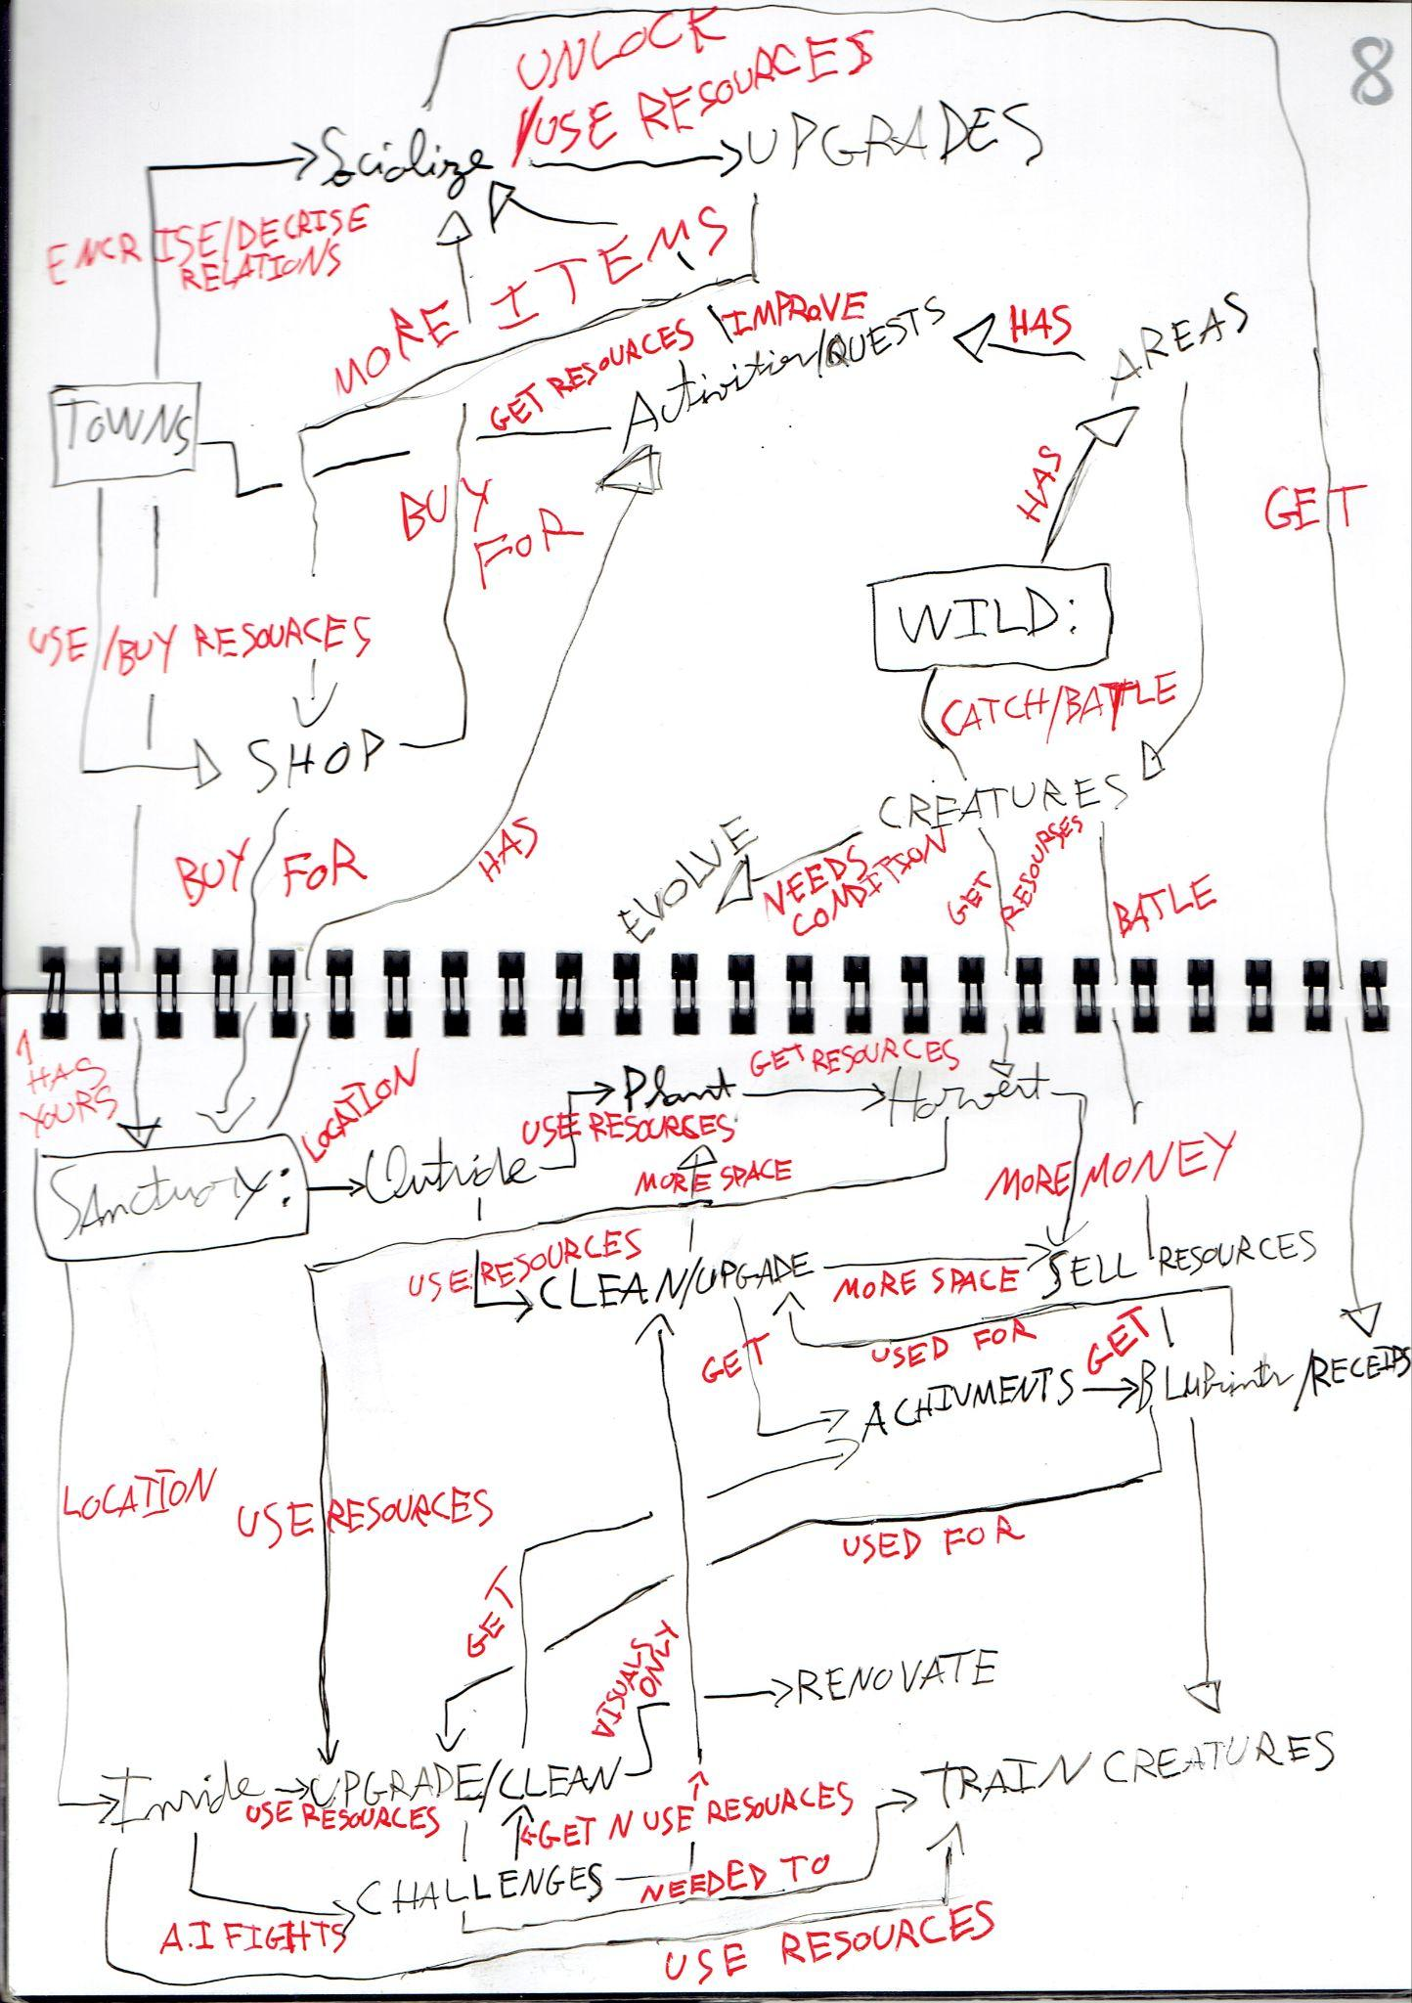

# **Game Elements**

## Main Characters

* **Player:**

Blank character, it represents the player wishes, however, they have some small personality traits like the will to explore or the unwillingness to take over the Sanctuary so they fit the themes of the story.

* **Character 1**

Charachter that introduces the mechanics and accompanies the player in the initial part of the game.

They are calm and nice, have a gentle voice and show concern for you

* **Character 2**

Main rival, shows slight disdain for the player because everyone shows interest in the player taking over the sanctuary but they think the player still has to prove themselves. It’s snarky to the player but not mean to everyone.

* **Your parants**

They have a cheerful personality, always happy, but always have evasive answers.

* **Character 3**

The researcher, will task you to find out more about the creatures, has a grumpy personality and only talks about the creatures, seems to ignore everything unless the creatures are involved (self absorbed)

* **Character 4**

Friendely rival, curious, easy going, but very lazy.

## Main Menu

The main menu will let the player check the status of their relationships, check their team and rearrange it, check and utilize their items, save the game, check missions status and progress and see the map.

## Intro Sequence

While I talked about it in the story and themes section, i did not tie it to gameplay. Therefore, I will use this section for that.

As the story start, you see the intro sequence without being able to move. After, the player is inside a room and receives a message on their “phone”. Following that, the player, which will be a dark blob, will have control of the character and will need to look in the mirror to proceed (appearance and others choice). The player will then leave the room and enter a vehicle leading them to their hometown. At the home town, they need to proceed to the sanctuary where they will meet someone that will give the player a helping hand settling in. As they enter the sanctuary and are cleaning some stuff, the player encounters 3 cards, here the player will be able to chose to go through the tutorial that the other person will give, or skip it and pick one of the cards, making the other 2 automatically get destroyed (choosing tutorial will also destroy the other 2 cards, but the narrative will differ as one will be an accidental touch and the other an intentional one). If the player choses tutorial, a wild creature will immediately enter the sanctuary making the other person capture it as a way to show how it is done. After this, the player will be able to free roam the sanctuary and the town starting the main game.

## End Condition

The end will have the twist mentioned before, having the player battle one of their parents (decided by certain decisions the player made, leaning towards depending on if the player has more sanctuary renovations or more adventures).

To reach the end the player will need to have a minimum % of sanctuary and adventure quests (combined), this implies the player will have all the zones unlocked and will have all the major fights completed. After reaching that point, the player will enter a locked story moment that they will not be able to skip (first playthrough only) where they will see the twist followed by the fight, depending on the social standing and points of sanctuary/adventure, the story post fight will also have some differences. The 2 main ways it can end is with the player realizing that when the player left home the parents were very worried as it seemed like the player was following a self destructive path; and the player having a heartfelt conversation with their parents and how hurt they are for their actions, being able to make peace at the end.

# **Sound**

## Music

**NOTE:** Although i personally believe music to be important, it is an afterthought in this GDD and thus not as fleshed out, do bear that in mind when listening to the proposed songs, thank you.

As the game is to be set in a world of victorian electric punk, there are few resources that accurately represent what i would like to see in the game, as such, I compiled a list of example musics that, fit the theme but would need a more electric overhaul.

The examples below will have 2 main genres of music, while they are different, I think they can be mixed and thus decided to keep both.

Main/standby theme:

* [01. Frostpunk Theme - Frostpunk Original Soundtrack](https://www.youtube.com/watch?v=uLF6VFME2jc);
* [Clockwork - Aviv Yeyni - JazzFez](https://www.youtube.com/watch?v=qfEpCqr_8jA).

Battle theme:

* [Steampunk Lady](https://www.youtube.com/watch?v=Ze2NiBA-YLA&t=2047s);
* [The Resistance](https://www.youtube.com/watch?v=Ze2NiBA-YLA&t=3433s);
* [Dystopia Now - abneypark](https://www.youtube.com/watch?v=4j3HbaMPg20), ignoring the lyrics/vocals.

Boss theme:

* [The Shadow Empire](https://www.youtube.com/watch?v=Ze2NiBA-YLA&t=2323s);
* [Sky Cadet Academy](https://www.youtube.com/watch?v=Ze2NiBA-YLA&t=3659s);
* [Général Lavine – eccentric: Dans le style et le mouvement d'un Cakewalk](https://www.youtube.com/watch?v=yx5P4j2DkHg);
* [2009 Sherlock Holmes movie - hans zimmer](https://youtu.be/oXLodky50zM?si=8gtm2d13C97pT4wx&t=64), more specifically, the way the strings are made and ignoring the fast drums;
* [Scallywag Swing - abneypark](https://www.youtube.com/watch?v=LmqgdYnW5hY), ignoring the lyrics/vocals.

“Final” enemy theme:

* [Albion - Alexander Shalyapin](https://www.youtube.com/watch?v=VrdAp0L67iI);
* [“Misconception” by Myuu](https://www.youtube.com/watch?v=WcbYxgo2qoc).

City/area or story moment theme:

* [The Gentleman](https://www.youtube.com/watch?v=Ze2NiBA-YLA&t=1083s);
* [Deeplamp Town](https://www.youtube.com/watch?v=Ze2NiBA-YLA&t=1779s);
* [Nocturne in E Flat Major, Op. 9, No. 2](https://www.youtube.com/watch?v=zql8G-4gE7w);
* [Franz Liszt - Liebestraum - Love Dream](https://www.youtube.com/watch?v=KpOtuoHL45Y);
* [Discombobulate - hans zimmer](https://www.youtube.com/watch?v=vgRVJksQocM);
* [Illusions and Smoke](https://www.youtube.com/watch?v=Ze2NiBA-YLA&t=0s);
* [Chanson de Matin by Sir Edward Elgar](https://www.youtube.com/watch?v=9s50XAbh7ro);
* [Clockwork - Philipp Klein](https://www.youtube.com/watch?v=DTf_VYDqPuE).

## Sound Effects

Mundane things are meant to use “realistic” sound effects, like walking, while the other sounds are meant to be more unique as to signal that you are in a different world.

## Voice Lines

The main story moments and the “main” side missions are to be voice acted, including all the creatures.

# **Mini Art Bible**

## Art Style

The overall appearance will be of a late Victorian era but with a reimagination of what the world would be like if the “steampunk” concept were to be applied to electricity. These would also portray a bit of innovation alongside familiarity and antiquity, making a parallel with the player's journey of coming back to their earlier life/home, while still creating a new path for themselves.

## Characters

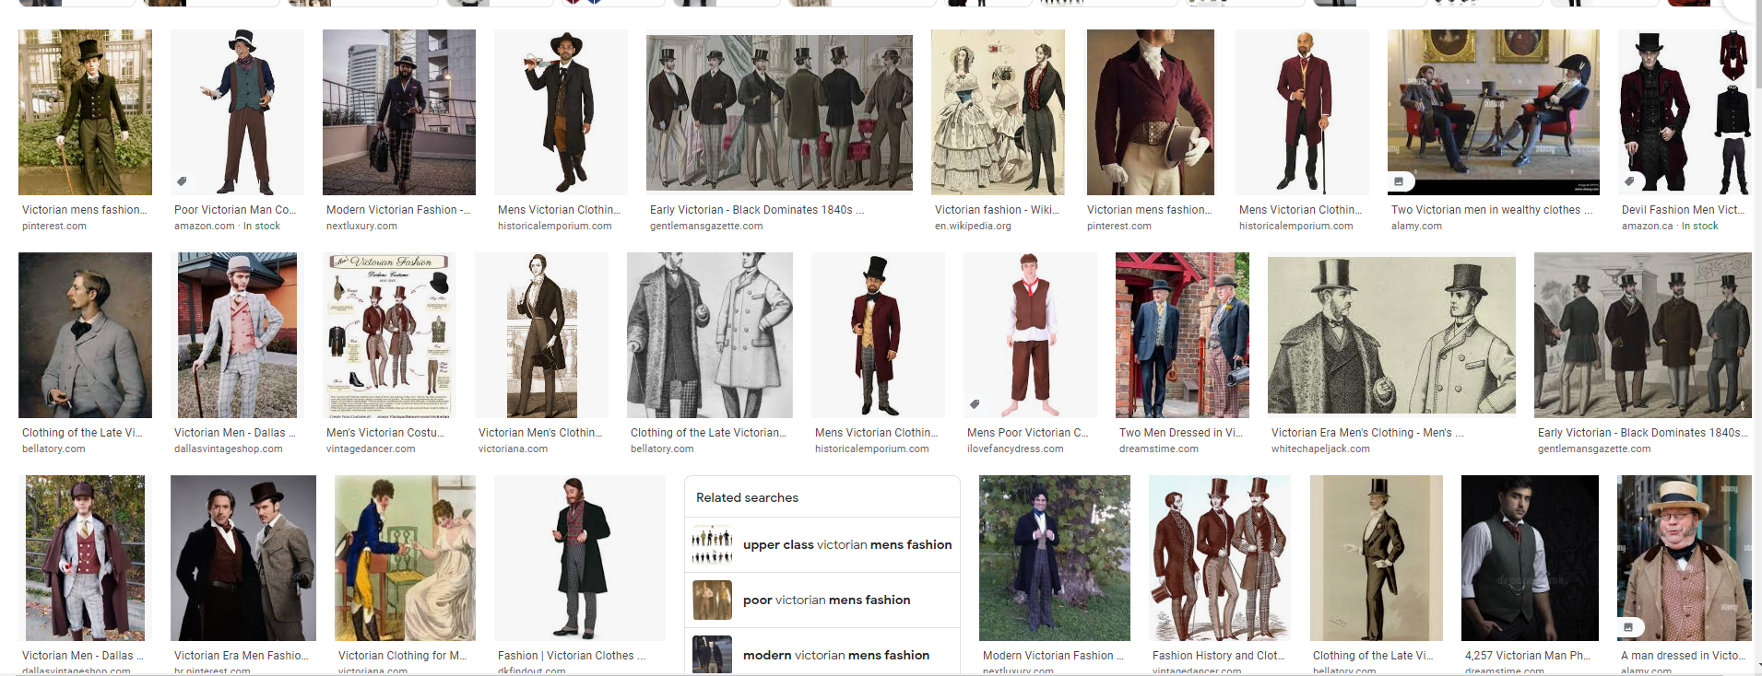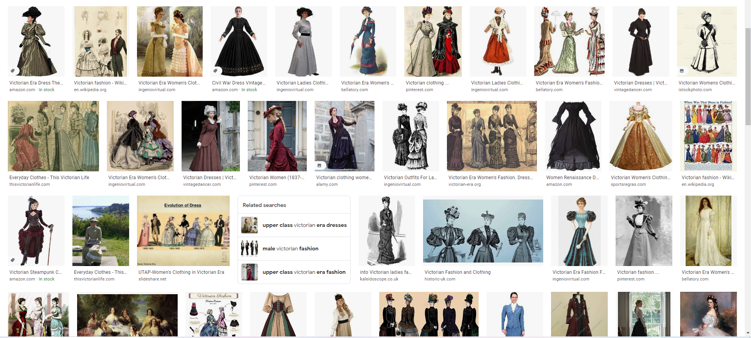

## Backgrounds/Levels

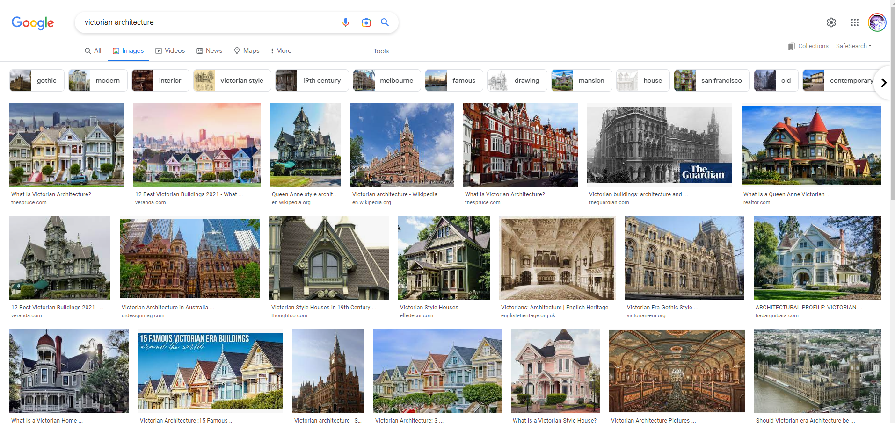

## Others

TBD

# **Implementation Pipeline**

While this section is separated into major “systems” to be implemented, for an ease of separation, many minor systems that need to be implemented as preparation are included in the major categories.

1. Turn base system (and closely related systems):

* Player movement;
* Simple player camera;
* Creature Stats script;
* Attacks script;
* Creatures in the overworld (spawner with different creatures);
* Player primary inventory;
* Creature “disposal”;
* Creatures encounter;
* Fighting system, UI movement and selection;
* Fighting system, attacks/hp management;
* Player secondary inventories (and others);
* Inventory/script, items;
* Fighting system, items;
* Fighting system, capture;
* Simple AI movement (movement inside area);
* Encounter Zones;
* Encounter Tables;

1. Farming system (and closely related systems):

* Grid map;
* Grid placement and removal;
* Simple Timing growth;
* Specific item placement restrictions;
* Item catalogue;
* Player interaction with objects;

1. Character Interactions

# Character script;

* Character movement;
* Interaction;
* Dialogue;
* Likeability;
* Gifts;
* Character inventory;
* Character Battle;
* Creature Trades;

1. Sanctuary, map and buildings

# Healers;

# Shops;

# Conditional Unlocks;

* House entry (load/unload assets);
* Day/Night System
* Sanctuary Challanges (based on day)

1. Story

# Event handler;

* Custom sequences;
* other stuff;

# 

1. Art

* No Order

# 

# 

# 

# 

# 

# 

# 

# **The team:**

**Francisco Borges: fjoborges@gmail.com**